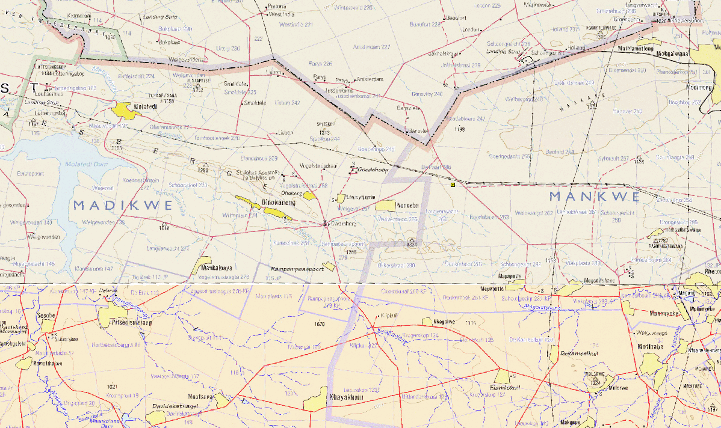

Dwaalboom switching station

**Locality Map**